Name | _________________________________________________________________
Address | _________________________________________________________________
Phone | _________________________________________________________________
Email | _________________________________________________________________
Expected Graduation Year ____________________$$$ AMOUNT ENCLOSED ___________
Cost: $26.00 per shirt
Pay by check only - print student’s name on check if not the same
Make check payable to VAPSS–ORDERS ARE DUE BY September 5th, 2014!
Indicate quantity for desired polo shirt size below.
Mail this form and check to the address at the bottom

*This is a recommended purchase for students
*Faculty, Staff, Family members, and friends may also purchase
Check sizes carefully! There are no exchanges!
MEN
Shirt Size | Equiv. Chest Measurement | Quantity | Color
Small | 34-36
Medium | 38-40
Large | 42-44
X-Large | 46-48
XX-Large | 50-52
XXX-Large | 54-56

WOMEN**
Shirt Size | Equiv. Dress Size | Equiv. Bust Measurement | Quantity | Color
X-Small | 0-3
Small | 4-6 | 32-33
Medium | 8-10 | 34-35
Large | 12-14 | 36-38
X-Large | 16-18 | 40-42
XX-Large | 20-22
**Especially for ladies, the polo will come in a lady’s cut for better fitting.
Questions?? Please email Thuy-Duong Lam (tdlam3@uh.edu) or Vicky Nguyen (Nguyenmvicky@gmail.com)

Mail check and form to: Thuy-Duong Lam
5514 Griggs Rd Apt#1810
Houston, TX 77021

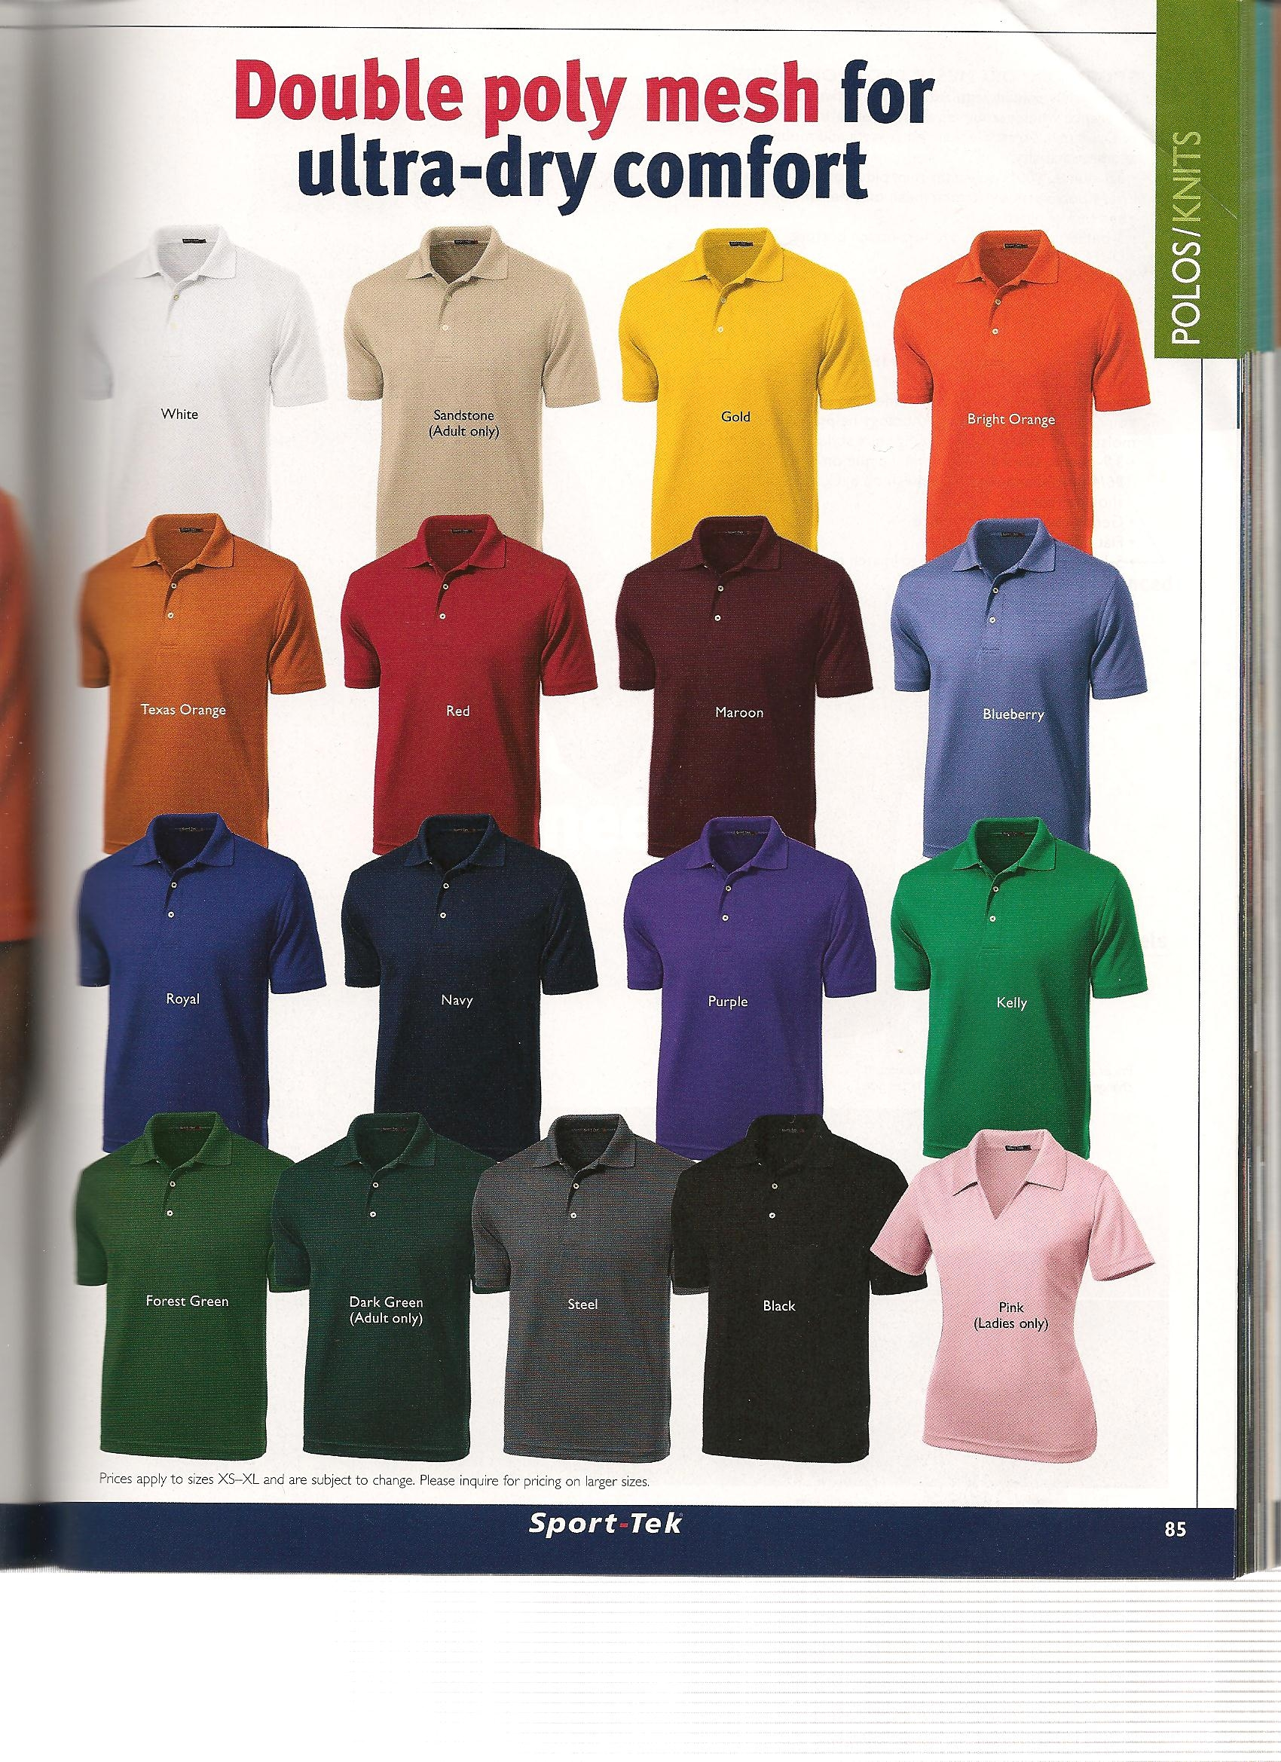
UH COP Logo will be on the left chest in white lettering.

